PHIL 3501: Philosophy of Art
Professor Saam Trivedi
Tuesdays & Thursdays 11:00 AM - 12:15 PM
Spring 2022

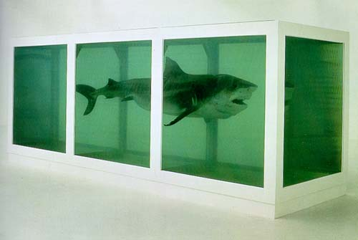

Some time back, the Metropolitan Museum of Art installed the artist Damien Hirst’s work “The Physical Impossibility of Death in the Mind of Someone Living,” consisting of a large glass tank holding a 13-foot tiger shark preserved in formaldehyde. But is that art?

More generally, what is art? Can we define art, and if so, how? Do artistic intentions matter to interpreting artworks? What is the relation between beauty in art and beauty in nature? How can we care for fictional characters given that we know they are not real? What role does music play in a culture? Why do many people seek out and enjoy horror films even though they arouse fear? What is the value of art?

Using both classic and contemporary readings and appropriate examples from the various arts, this class will discuss philosophical issues such as the above that pertain to art.

