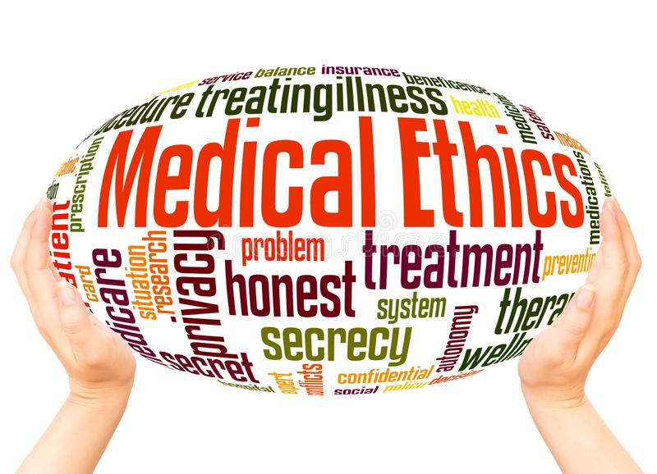

PHIL 3316
Medical Ethics
Prof. Christine Vitrano
Tues. / Thurs. 11 – 12:15

As biomedical technology progresses, we face new challenges to our traditional moral beliefs and practices. Medical ethics is the study of the moral issues and problems associated with the practice of medicine and the pursuit of biomedical research, and it deals with a broad spectrum of concerns that affect patients and their families, physicians and researchers, society, and even the unborn.
In this course, we will approach these ethical issues through an examination of real cases covering topics ranging from the familiar (abortion, suicide, euthanasia) to the more obscure (assisted reproduction, cloning and medical enhancement). We will also discuss how doctors should handle requests to die from terminal and non-terminal patients, whether it is permissible to end life-sustaining treatment in comatose patients, and how we ought to treat severely impaired babies.
If you have any questions or would like more information about this course, please email me at cvitrano@brooklyn.cuny.edu.

