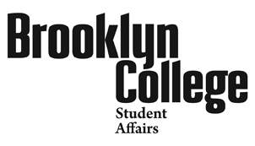
Student Behavior Form (SBF)
Office of Judicial Affairs, 2113B, 718.951.5352

Use this form to report troubling student behavior of concern that you may be aware of. If you are reporting a crime it must also be reported to the Office of Public Safety*. After you complete and save the form, please email it to mcunningham@brooklyn.cuny.edu.

Part 1: What is this concern regarding? (check all that apply):

Part 2: Describe the behavior or incident (Use additional sheets if necessary)
Part 3: Follow-up Action requested (check as many as are relevant):

* Members of the Campus Community, specifically victims, witnesses and counselors may report a crime anonymously to the Director of Campus & Community Safety Services at any time via the hotline number, (718) 951-4628.
EMERGENCY: If help is needed immediately, call the Office of
Public Safety, 718-951-5511. Then, alert the Office of Judicial Affairs
In Student Affairs, 718-951-5352 at the earliest opportunity.

SBF Rev:3/29/11

