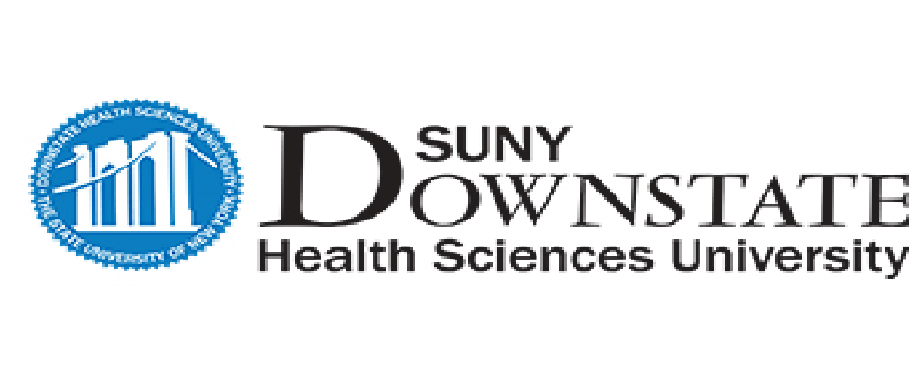
University Hospital of Brooklyn
College of Medicine
School of Graduate Studies
College of Nursing
School of Health Professions
School of Public Health

MEMORANDUM OF UNDERSTANDING
SUNY Downstate Health Sciences University
School of Health Professions & Brooklyn College
City University of New York
SUNY Downstate Occupational Therapy Program
(MSOT)
This Memorandum of Understanding (MOU) is between the Occupational Therapy
Program (MS) at SUNY Downstate Health Sciences University and Brooklyn College City University of New York Both parties will:
- Collaborate on and share information for the admissions process for the Occupational Therapy program at SUNY Downstate for applicants from Brooklyn CUNY for the duration of the program’s admissions cycle for the listed term below
- Collaborate on virtual information sessions specifically designed for Brooklyn CUNY students who are applying to the Occupational Therapy program at SUNY Downstate
- Collaborate on advising Brooklyn CUNY students who are applying to the SUNY Downstate Occupational Therapy program
SUNY Downstate Occupational Therapy Program will:
- Provide group based mentoring and group based advisement sessions to all Brooklyn CUNY applicants who have applied to the Occupational Therapy program for the term listed below
- Will implement a admissions priority system (early interview and early decision) to all qualified applicants who apply to the program prior to the admissions close date for that academic year, for the academic term dates listed below, in accordance to the program and institutions admissions and matriculation polices
Brooklyn CUNY will:
- Collaborate with the SUNY Downstate Occupational Therapy program in identifying at least 5 qualified candidates for the admissions priority process for the terms listed above
- Brooklyn CUNY will screen and identify students who meet the following basic criteria:
o A cumulative GPA of at least 3.0 of higher o Documented leadership activities and or community service ventures o Has attended at least 1 SUNY Downstate OT program information session o Has completed the SUNY Downstate OT program online learning modules available from the SUNY Downstate OT webpage

PERIOD OF AGREEMENT
The participating parties agree to the terms outlined above for August 2021 to January 2022 with plans to review these terms at the conclusion of the noted academic year.

APPROVAL

I have read and agree to the terms and conditions outlined above.

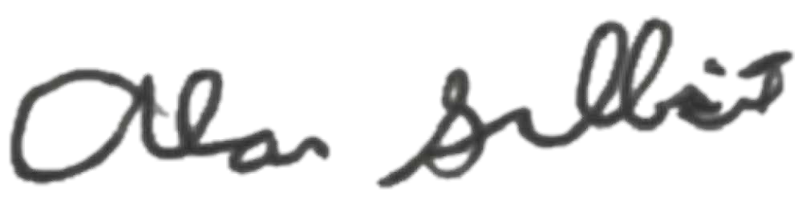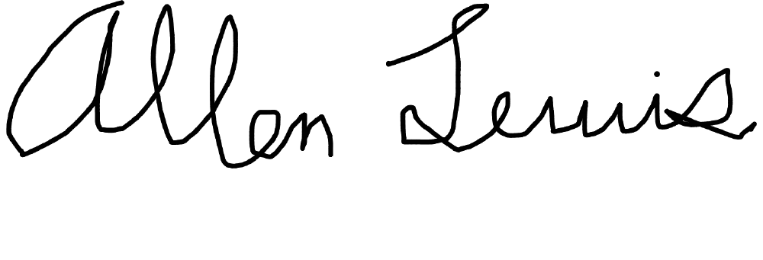

SUNY Downstate Occupational Therapy Program Representative
Date

Brooklyn CUNY Representative

Date

11
/12/
20
12/14/2020

