Philosophy 3725: Philosophy of Race
Spring 2022 MW 12:50 – 2:05
3 credits, 3 hours
Professor Kobie Colemon, Ph.D.

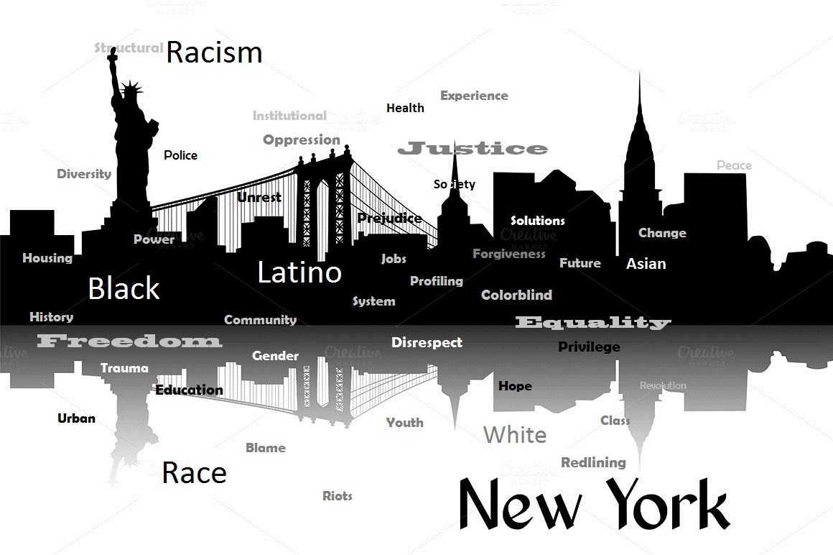

This course offers a philosophical examination of race and the question of its validity as a scientific, social, and census category. We will explore such issues as the metaphysical legitimacy and social reality of racial designations; race, subjectivity, and sense of self; mixed race persons; racial identities and their political effects; the continued use of racial categories as social/cultural norms; and the persistence of racism—including the renewed focus and contemporary discussion of Critical Race Theory in mass media/popular culture.

Partial Reading List

The Racial Contract by Charles Mills
How We Get Free: Black Feminism and the Combahee River Collective
by Keeanga-Yamahtta Taylor
The Man-Not: Race, Class, Genre, and the Dilemmas of Black Manhood by Tommy J. Curry
Latinos in the United States: The Sacred and the Political, by David T. Abalos
Visible Identities by Linda Martín Alcoff
Faces at the Bottom of the Well by Derrick Bell
Black Skin, White Masks by Frantz Fanon
“Postmodern Blackness”, in Yearning: Race, Gender, and Cultural Politics by bell hooks
The Ways of White Folks by Langston Hughes
Good Muslim, Bad Muslim by Mahmood Mamdani
Everybody was Kung Fu Fighting by Vijay Prashad
Race and Mixed Race by Naomi Zack

