# Appendix A:

# The Brooklyn College Worksheet for Identifying and Defining AES Unit Goals

## Brooklyn College Worksheet for Identifying and Defining AES Unit Goals

*After each assessment team member has completed this worksheet, compare notes and discuss the results. Then summarize and articulate primary goals.*

|  |
| --- |
| **Division:**  **Unit:**  **Identify the Unit mission and list all appropriate Unit goals.**  **Describe the most important services your Unit provides.**  **Identify key functions or services within your Unit that contribute to supporting the College’s mission and/or strategic plan.**  **For each key function or service, ask how Brooklyn College:**   1. **Operates more effectively as a result of your service** 2. **Can support students because of your service** 3. **Benefits from utilizing your service**   **In what ways should your Unit make a difference in successful outcomes for Brooklyn College students, faculty, staff, and other administrative Units?**  **Articulate 3-5 Goals which align with your Unit mission** |

### Appendix B:

### Sample Detailed AES Assessment Planning Document

 *Adapted from planning documentation from The Learning Center*

**SAMPLE**

### Appendix C:

### Glossary

## Glossary

Administrative Unit: An office responsible for the operational activities within an educational institution.

AES Assessment: Administrative, Educational and Student Support Unit Assessment - the assessment of the effectiveness of non-instructional units within an institution.

Alignment: The degree to which the components of an education system—such as standards, curricula, assessments, and instruction—work together to achieve desired goals (Ananda, 2003; Resnick, Rothman, Slattery, and Vranek, 2003; Webb, 1997b).

Assessment: A systematic process of gathering and analyzing information to see if your division, unit, or program is meeting its goals, objectives, or outcomes and then using that information to make improvements

Assessment Instrument: A tool or instrument used to assess administrative operations and units. A commonly used tool is a rubric for performance appraisals. To learn more about assessment instruments, please refer to the Brooklyn College AES Assessment Handbook.

Assessment Method: The method used to assess unit outcomes. This can be a short description of the unit activity or process and the assessment instrument (e.g., locally developed rubric) used.

Assessment Results: The quantitative or qualitative results of the assessment of unit performance. This can be presented as short paragraph, a graph, a table, etc.

Direct Measures: For student learning outcomes (SLOs), these are the measurements of student knowledge, behaviors and learning linked to specified SLOs.

Data Source: The origin of the data used to answer a research question. In the context of this document, the data source is the sample and sampling method description for data collection.

Division: A department within an institution. At Brooklyn College, there are five divisions under which numerous offices (units) are housed, including Academic Affairs or Enrollment Management and Retention, for example.

Documentation: Materials that provide evidence or record of certain activities, decisions, or planning.

Evaluation: The process of assessing the value, worth or effectiveness of an initiative, program, process or curriculum; evidence-gathering processes that are designed to examine unit, program, or institution-level effectiveness.

Goals: The general aims or purposes of an educational system, often at the unit or program level, that are broadly defined and include intended outcomes.

Indirect Assessment: The measurement of student learning experiences often linked to direct assessments but not measuring student learning outcomes. Consequently, indirect assessments can include opinions or thoughts about student knowledge, values, beliefs and attitudes about educational programs, processes and curriculum. They may also include measures of student outcomes like retention rate, course grades or GPA that are not direct assessments of the student learning outcomes.

Initiative: A general term for a strategy, program, product, service, or project.

Institutional Effectiveness: How well an institution meets its mission and goals, as well as meeting stakeholder needs, deploying resources effectively, prudently, and efficiently to ensure an institution’s well-being, serving the public good, and demonstrating an institution’s quality and effectiveness in fulfilling its responsibilities (Suskie, 2014).

Mapping: Identifying where outcomes are aligned with a mission, goals, or initiatives.

Mission: An institution’s mission defines its purpose within the context of higher education, the students it serves, and what it intends to accomplish (MSCHE, 2018).

Operational Outcomes: Outcomes that reflect the core mission and purpose of the administrative unit by stating the expected results. Operational outcomes are generally assessed to ensure effectiveness of the unit at meeting its mission. Accordingly, operational outcomes are written in present tense.

Outcomes: The results of programs including behaviors, knowledge, skills and level of functioning. They are usually measured as an assessment. For SLOs, they can be measured using a performance appraisal or a test.

Performance Target: A quantitative benchmark for assessing achievement. For example, if one the quality of a service using a rubric for performance appraisal, a target can be set as 70% of servicers meeting or exceeding expectations.

Planning Document: A document that calendars the assessment of outcomes for a program, initiative, program, or unit, and outlines when the outcomes will be assessed. A detailed planning document also includes the unit goals, assessment methods, coordinating staff, and dates for evaluation, improvement planning, and re-evaluation of unit outcomes.

Results-based Changes: Changes made within a division or unit based on the analysis of the assessment results. These changes attempt to remedy or better any areas or processes needing improvement as identified by the assessment process.

Rubric: A tool used in assessing student artifacts, e.g., oral exams, research papers, and capstone projects, or in assessing unit processes, e.g., services, activities, and procedures. Assessment rubrics are useful because they list clear expectations of performance and provide a way to rate student work and unit operations.

Sample: A selected subset of a population, ideally representative of the whole.

Sampling Method: The way in which the sample from the population is selected.

Strategic Outcomes: Outcomes that reflect future expected results of the unit, based on a planned activity. Strategic outcomes are generally assessed as part of the planning process to ensure strategic initiatives have the intended or positive results. Accordingly, strategic outcomes typically are written in future tense.

Student Learning Outcomes: (SLOs) are behavioral statements that specify what students will learn or can do as a result of a learning program, process, or curriculum.

# Appendix D:

# Examples of Assessment Measures

## Examples of Administrative Assessment Measures

A table of examples of administrative assessment measures is below. These measures are categorized by assessment of unit processes, unit initiatives, and unit customer/client/end-user satisfaction. For more examples of assessment measures of administrative unit performance, please contact your division’s AES Council representative for access to the *2019 CAS Standards*. Additional language guidance for AES assessment of unit outcomes can be found in the *Brooklyn College AES Assessment Handbook*. For examples of measures of student learning, please see *Examples of Evidence of Student Learning* on the next page.

|  |  |  |
| --- | --- | --- |
| **Measures of Unit Processes** | **Measures of Unit Initiatives** | **Measures of Satisfaction** |
| * Auditor’s findings * Average service time * Average wait time * Comparison to professional standards * Deviation from annual plan * Level of compliance * Number of complaints * Number of errors or error rate * Processing time for requests * Staff training hours * Timeliness of response | * Awareness surveys * Number of applications & percentage change * Number of new/alumni/parent/faculty and staff donors * Number of training sessions & growth in attendance * Number of users & percentage change * Number/amount of donations, percentage increase * Pre- and post-workshop tests (tied to SLOs) * Satisfaction surveys, tied to outcomes * Staff training hours, tied to outcomes | * Activity participant feedback * Customer, client, or visitor satisfaction forms * Focus groups * Opinion surveys * Satisfaction surveys |

*Adapted from the Marymount University Administrative Assessment Guide*

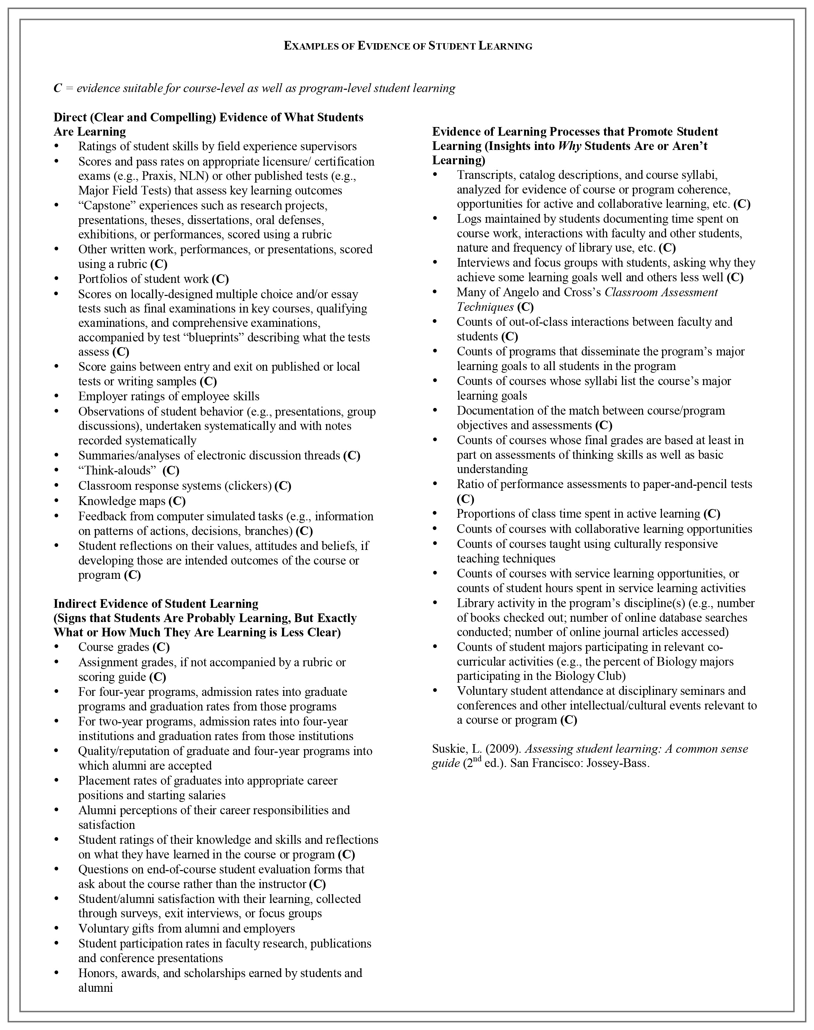 Reprinted from *Examples of Evidence of Student Learning*, in the Middle States Commission on Higher Education.