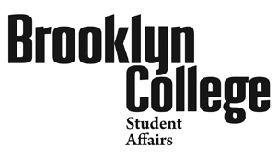
Student Behavior Form (SBF)
Office of Judicial Affairs, 2113B, 718.951.5352, Discipline@brooklyn.cuny.edu

Use this form to report troubling student behavior of concern. If you are reporting a crime it must also be reported to the Office of Public Safety*. Completed forms can be hand delivered or sent via interoffice mail to the attention of Judicial Affairs in 2113B, or by e-mail to Discipline@brooklyn.cuny.edu.

Your Information:

Reported Student’s Information:

Part 1: What is this concern regarding? (check all that apply):

Part 2: Describe the behavior or incident (Use additional sheets if necessary)

Part 3: Follow-up Action requested (check as many as are relevant):

* Members of the Campus Community, specifically victims, witnesses and counselors may report a crime anonymously to the Director of Campus & Community Safety Services at any time via the hotline number, (718) 951-4628.
EMERGENCY: If help is needed immediately, call the Office of
Public Safety, 718-951-5511. Then, alert the Office of Judicial Affairs
In Student Affairs, 718-951-5352 at the earliest opportunity.

SBF Rev:09/10/20

